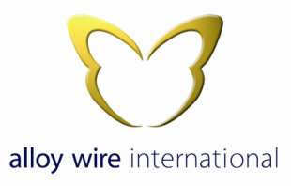

Human Rights Policy

Alloy Wire International is committed to identify and prevent any business practices that infringe on human rights by complying with all applicable guidelines set by UK law. The following will continually be respected and adhered to throughout the organisation.

- Equal rights for all employees, regardless of religion, race, nationality, disability, sexual preference, political stance, sex or age.
- Zero tolerance of any form bullying or abuse whether it be physical or mental.
- Zero tolerance of any form of threatening behaviour including language, gesturing or physical contact.
- Zero tolerance of any form of Sexual harassment.
- To protect personal privacy and Data of all employees and customers.
- No employee will be forced to work against their will or without the necessary training and or equipment needed to carry out that individual task.
- To operate in full compliance with UK wage structure, work hours (including overtime) and benefit law.
- Prohibit Child labour, with no hiring of any individual under the age of 16.

Alloy Wire International believes that its people are its most important asset and that people contribute most effectively to the success of Alloy Wire International and achieve job satisfaction, if they are healthy and happy at work.

Whilst it is the Company’s intention to provide assistance and support to all of its employees, it will take disciplinary action, including dismissal, if any of the above are breached.

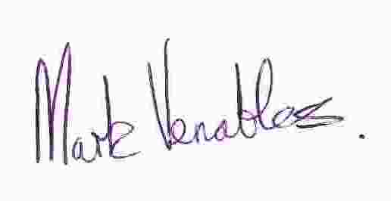
Signed:

Mark Venables
Managing Director
1st August 2017.

